# Administrative Core / Overall

*The AViDD Overall Progress Report is from the Administrative Core*

# 1. SAB Narrative

*Provide a Scientific Advisory Board (SAB)-generated narrative that addresses the following points:*

*Describe how the Management Plan has guided AViDD activities during the project period, whether it has changed, and how the plan will guide activities during the next project period.*

The ASAP Management Plan is operating as described in the Administrative Core Research Strategy, with the exception of replacing Ben Perry (who transitioned to join Medixi) with Peter Sjö (DNDi) as PI and Annette von Delft (MedChemica) as Project 6 Lead. Ben Perry has been added to the internal Scientific Advisory Board. New investigators brought into ASAP during the project period have been consolidated into Projects and Cores under their corresponding leadership.

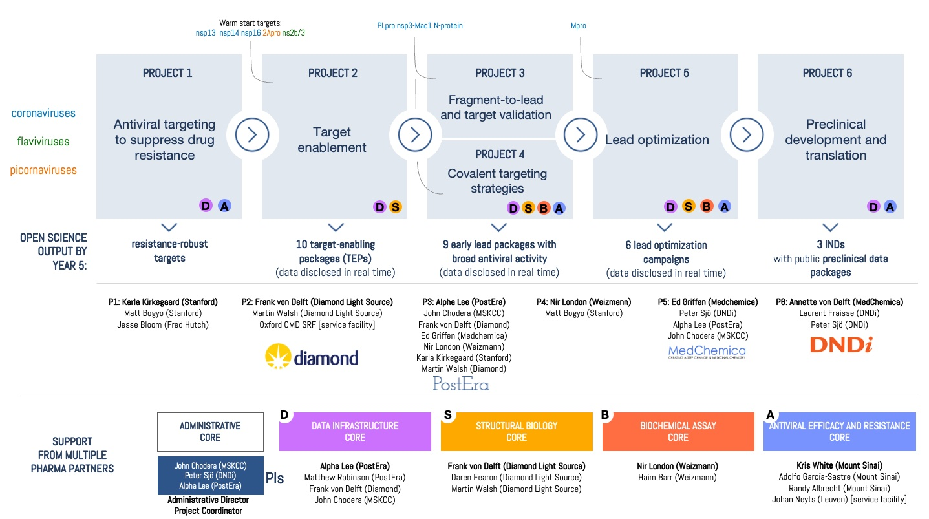

Administrative Core 1.4.2 Internal Center coordination: We currently hold weekly meetings with ASAP Investigators to ensure close coordination among Cores and Projects. The focus of these meetings rotates between (1) monthly all-hands meetings, (2) discussion of long-term strategy among Leads and other members, (3) science updates shared by Projects and Cores, and (4) a monthly Antiviral Drug Discovery Open Science Forum [<http://openantivirals.org>] that includes talks from and discussions with other AViDD Center investigators. In addition, cross-functional meetings between Project 1 (P1) and P2 are held weekly to coordinate target nomination and handoffs between these projects, while Program (target) focused meetings are held weekly for P5 lead optimization campaigns that include representatives of all relevant Cores.

During the next project period, the ASAP Management Plan will continue to operate as described in the Administrative Core Structure.

*Document interdependence between and among the Research Projects during the project period. Is there evidence of synergy among the Research Projects and Cores?*

As described in the Management Plan, ASAP is organized like a drug discovery biotech: Discovery Programs (focused on a Targeting Opportunity and breadth of viral family members) progress primarily sequentially from Project to Project (via the Administrative Core Research Strategy Section 1.5.2 Program Progression Process):

* The definition of Targeting Opportunities and nomination of Discovery Programs is a collaborative effort between P1 and P2 to select viable targets within our remit, with input from P5, P6, and the external Scientific Advisory Board in crafting appropriate draft Target Product Profiles (TPPs). The full SAB is then engaged to review and approve the Programs that have been initiated by P2, as well as deep mutational scanning (DMS) efforts in P1. This inter-project process has resulted in the definition of at least 22 potential Targeting Opportunities and the full detailed development of 7 targeting opportunities to date on the ASAP website, along with Target Product Profiles for all Programs that have entered P3.
* Target Enabling Packages (TEPs)---which provide X-ray fragment screens and validated assays—are produced by P2 based on these collaboratively defined Targeting Opportunities, and move into P3 and P4. The Biochemical Assay Core reformats these assays for high-throughput and the Structural Biology Core generates X-ray structures. At least 32 TEPs have been initiated, and 10 have completed X-ray fragment screens.
* Programs then progress to P3 (fragment-to-lead) and P4 (covalent targeting strategies) to generate lead compounds suitable for P5 (lead optimization). P5 assists in defining a Target Lead Candidate Profile that specifies criteria for leads acceptable into P5 Lead Optimization programs. All P3/P4 activity is supported by the Antiviral Efficacy and Resistance Core, the Biochemical Assay Core, and the Structural Biology Core. At least 5346 compounds have been synthesized and assayed by P3/P4 in this coordinated manner to date.
* Programs that progress into P5 (lead optimization) work closely with P6 to define a Target Candidate Profile (TCP) that specifies criteria for candidates acceptable into P6 (preclinical development). At least 882 compounds have been synthesized and assayed by P5 for the MERS-CoV/SARS-CoV-2 Mpro program. P5 and P4 have collaborated on chemical series with covalent warheads for this program. All P5 activity is supported by the Antiviral Efficacy and Resistance Core, the Biochemical Assay Core, and the Structural Biology Core. Public data disclosure is governed by the IP policy developed in collaboration between P6 and P5.

The Data Infrastructure Core and Administrative Cores support all Projects and Cores in the coordination, use, and sharing of data and coordination of activities, and collaborate closely in this work.

*Describe any weaknesses or deficiencies that have materialized and how they are being addressed.*

Deep mutational scanning:In Year 1, insufficient laboratory support for deep mutational scanning (DMS) activities across targets of interest to ASAP was rapidly identified as a deficiency by P1. This led to the integration into P1 of the Bolon/Flynn/Schiffer laboratories (UMass) to provide immediate DMS support for the SARS-CoV-2/MERS-CoV Mpro Program in P5; Evans/Richardson (Sinai) to support DMS activities for Zika polymerase, protease, and capsid; Lindebach (Yale) was awarded a Developmental Award to provide DMS (via eMAGE) for additional SARS-CoV-2 targets in Year 2. The Bloom lab also analyzed circulating SARS-CoV-2 variants to provide complementary data on mutational tolerance to inform resistance-robust inhibitor discovery. These activities have now generated a significant amount of deep mutational scanning data that are now integrated into all aspects of discovery via an interactive Fitness Viewer, with subsequent work on automated scoring for large-scale free docking and energy calculations underway.

Enzyme inhibition modeling support: A lack of enzyme assay modeling to support MERS-CoV Mpro biochemical assay estimation of affinity to the active dimer form was identified as a deficiency in supporting the SARS-CoV-2/MERS-CoV Mpro Program in P5, leading to a subaward to integrate modeler Minh (IIT) into the Biochemical Assay Core starting 1 May 2023. This has enabled us to more robust fitting procedures for estimating biochemical potencies, as well as the ability to determine Kd estimates for the MERS-CoV dimer, which correlate better with antiviral efficacy data.

Inter-AViDD coordination: A lack of central coordination between AViDD Centers was identified as an issue that risked significant duplication of effort between Centers. Together with the SGC component of the READDI-AC Center, we initiated the Antiviral Drug Discovery Open Science Forum [<http://openantivirals.org>] that provides a monthly forum for AViDD Center researchers to share updates and resources of use to other AViDD Centers. This forum has continued to provide highly useful avenues for inter-AViDD coordination and sharing of useful data and resources. We hosted 24 talks and 12 monthly Open Antiviral Drug Discovery Forum sessions over the reporting period, all of which are archived publicly online at the forum website.

IP policy: Progression of the COVID Moonshot predecessor project through the preclinical stage toward IND-equivalent filing and subsequent clinical development provided valuable insight into how ASAP’s IP strategy should be refined to balance the goals of global equitable access and open science. This insight was incorporated into a draft IP policy by P6 that guides our current operations: All data generated by P1-4 will be immediately disseminated, while some data from P5 will be delayed pending filing of single-compound patents held by organizations committed to licensing strategies that ensure global equitable access, with patents filed with the earliest possible publication dates. P6 data will be released upon IND-equivalent. This IP policy is in the process of being executed by all ASAP member organizations, and both a publicly-accessible explainer and a detailed preprint to enable others to follow the same strategy will be released shortly.

Triaging Discovery Programs: With early feedback from the external SAB who were concerned that running too many Discovery Programs simultaneously could detract from focus in both attention and resources, we have initiated a strict process to carefully review Discovery Programs entering and within P3. This has led us to pause or halt programs that were not maximizing our likelihood to succeed, as well as our ability to exploit ASAP’s unique platform capabilities. This process led to pausing/halting several programs in P3, including SARS-CoV-2 nsp3 Mac1 macrodomain and SARS-CoV-2 N protein.

Focus on Discovery Programs with greatest chance of successfully reaching key milestones due to abrupt end of funding: To attempt to address the abrupt change in funded duration—from the originally planned five years to three years—and enable programs to reach key milestones that will allow them to potentially continue progressing under funding sources other than AViDD or organizations other than ASAP, the SAB has been advising us on remaining nimble in pivoting to focus our effort on those programs with the highest chance of success as new data becomes available. Continual prioritization to maximize success is key.

*Describe how supplemental funds (if any) impacted overall AViDD activities.*

Not applicable

# 2. Changes and Go/No Go Status

*Provide a narrative that addresses the following points:*

*What changes, if any, have occurred in the last year to the structure of the AViDD in terms of key objectives, activities, and/or personnel?*

Changes to key objectives: None.

Changes to major activities: Addition of Developmental and Mentored Award Programs

Changes to personnel:

Developmental Research Projects:

Bret Lindenbach, Yale University

Michael Waring, Newcastle University

Thomas Zwaka, Ichan School of Medicine at Mt Sinai

Mentored Research Projects:

Joshua Horton, Newcastle University

Warren Thompson, Diamond Lightsource

*Discuss the Go/No-Go status of each Research Project and Core.*

Because ASAP is organized like a biotech with Projects representing sequential stages of discovery and Cores supporting these activities, all Projects/Cores are essential and cannot be removed.

ASAP instead relies on the external SAB to advise on the progression of Discovery Programs from Project to Project (as described in the Administrative Core Research Strategy Section 1.5.2 Program Progression Process). This process has been critical in gating the progression of Discovery Programs into Project 5 (Lead OptimizatioNn) and Project 6 (Preclinical Development) where costs increase significantly.

# 3. Include the following 3 Sections

*For the AViDD Overall report, also include the following sections. If one of these items is not applicable to your AViDD during the project period, include the title and indicate “Not Applicable”.*

## 3a. Product Development

*Provide a SAB-generated narrative that address the following points:*

*Describe any advances in product development during the project period. Describe any industry/biotech/government interactions with your AViDD that directly affected the activities and research conducted by your AViDD related to product development. Discuss any Product Development issues/concerns/updates pertinent to your AViDD. If applicable, list all patent applications filed by your AViDD during the project period and any patents issued. For each, provide applicant name, application number, title, date filed, type (vaccine, diagnostics, therapeutics, other), and disease/agent associated with it.*

Preclinical development of MERS-CoV/SARS-CoV-2 Mpro program: With SAB approval, the MERS-CoV/SARS-CoV-2 Mpro program initiated the transition into Project 6, and monthly meetings between Project 5 and Project 6 have enabled planning for significant preclinical development activities to begin shortly (see **Project 6** report for details). An *in vivo* animal efficacy proof of concept milestone was reached by this program, with a compound in the late-stage lead series showing significantly more potent reduction in MERS-CoV viral load compared with nirmatrelvir (**Figure 1**; see **Project 5** and **Antiviral Core** reports for details).



**Figure 1. The ASAP MERS-CoV/SARS-CoV-2 Mpro protease program shows significantly greater potency in reducing MERS-CoV viral load compared with nirmaterlvir in an *in vivo* animal efficacy model.** 8HUM mice were transduced with Ad-hDPP4 and then intranasally infected with 1x105 PFU of MERS-CoV and treated orally BID with indicated doses of ASAP-0016506 or Nirmatrelvir. MERS-CoV titers in the lungs were determined on day 3 post infection. N = 10. Data was log-transformed and analyzed by two-way ANOVA (****P < 0.0001). **Detailed description appears in Antiviral Core progress report.**

COVID Moonshot preclinical development: ASAP directly interacts with the DNDi-led COVID Moonshot predecessor program, which leads a Wellcome Trust funded preclinical development program for a SARS-CoV-2 Mpro, and is using experience gained in this program to inform plans for ASAP coronavirus preclinical development programs.

NCATS collaboration: ASAP initiated a collaboration with NCATS to pursue early hit discovery for CHIKV nsp2 (protease) and nsp3 (macrodomain) by cross-screening ASAP protease- and macrodomain-targeted compound libraries to identify starting points for further discovery. All screening and assay activities were be carried out by NCATS. This collaboration was terminated by NCATS when APP funds were rescinded.

Pardes asset licensing: ASAP discussed the potential for in-licensing a second-generation SARS-CoV-2 Mpro inhibitor (both a candidate for clinical development and a backup lead series) from Pardes Biosciences, but—with SAB input—ASAP elected to terminate further consideration of licensing.

*Summarize any regulatory guidance (SAB, FDA or otherwise) that exists or has been released related to candidate product(s) being developed by your AViDD. What advances, if any, in regulatory science related to the product(s) being developed by your AViDD, have occurred at your AViDD and/or by others in the field during the past year?*

Not applicable

## 3b. Biocontainment/Biosecurity

*List all Research Projects/Cores that employed BSL3 and/or BSL4 facilities during the project period. For each listing, provide the following information:*

* Project Number: **U19 AI171399-01 8257**
* Project Title: **Antiviral Efficacy and Resistance Core**
* Project Leader(s): **Kris White**
* Collaborator(s): **Adolfo Garcia-Sastre and Randy Albrecht**
* BSL Laboratory Employed: **BSL3, E-BSL3**
* Pathogen(s) Evaluated: **SARS-CoV-2, MERS-CoV**

## 3c. Follow-on Funding

*List each follow-on grant or contract obtained by researchers in your AViDD that stems directly from AViDD research and/or product development activities. For each listing, provide the following information:*

* *Project Number*
* *Project Title*
* *Project Leader(s)*
* *New Project Title*
* *Source of new funding, duration and start date*

Not applicable

# A. Specific Aims

The Specific Aims have not been modified from the original, competing application.

# B. Studies and Results

*Highlight the most significant accomplishments from this Center during the past year*

ASAP uses AI/ML and computational chemistry to accelerate structure-based open science antiviral drug discovery and deliver oral antivirals for pandemics with the goal of global, equitable, and affordable access.

We have defined **ASAP Priorities** as:

1. Ensure antivirals are developed in a manner that enables global, affordable, and equitable access
2. Ensure ASAP antivirals could be rapidly accelerated through clinical development in emergent pandemics
3. Use open science to seed a global antiviral pipeline, provided this does not compromise priorities 1 and 2

ASAP is organized like a small biotech, where Discovery Programs flow into Project 1 and move sequentially until they reach IND-readiness at the end of Project 6. This organization is reflected in the structure of this Progress Report, which focuses on reporting the scientific outputs generated by each stage (Project):

ASAP has recruited an extraordinary Scientific Advisory Board (SAB) to help it meet its mission: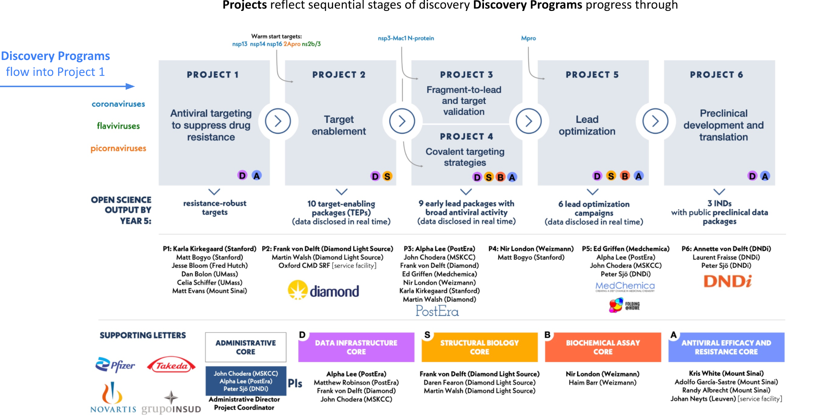

**Jeremy Burrows** is Head of Discovery for Medicines for Malaria Venture, and formerly Associate Director of Lead Optimization and Lead Generator at AstraZeneca. Dr. Burrows is a distinguished medicinal chemistry leader with expertise in non-profit drug discovery as well as pharma experience. Dr Burrows brings extensive expertise in drug discovery in the context of ensuring global equitable access to the SAB.

**Marti Head** is Executive Director of Computational and Data Sciences at Amgen, and was formerly a Director at the Oak Ridge National Laboratory coordinating the National Virtual Biotechnology Laboratory response to COVID-19. Prior to that, Dr. Head headed Insights From Data at GSK, in addition to having served as Senior Director of Computational Chemistry. An expert in computational chemistry, with an illustrious career spanning pharma and federal organizations, Dr. Head brings expertise in computational chemistry strategy and organizational leadership to the SAB.

**Ann Kwong** was, until recently, Executive Vice President at Pardes, formerly at Executive Vice President of Research And Development at Dewpoint, Vice President of the HCV Franchise and Head of Infectious Diseases at Vertex, and Principal Scientist of Antiviral Chemotherapy at Schering-Plough. She is a renowned leader in virology drug discovery, having led the discovery of the HCV protease inhibitor telaprevir and pimodivir. She also founded the Public Benefit Corporation Trek Therapeutics, to bring affordable HCV therapeutics to market. Most recently, she led the clinical development of PBI-0451 for COVID-19, which has generated extraordinarily relevant learnings for ASAP’s efforts. Dr Kwong brings expertise in virology in the context of drug discovery, and a pro-public health approach to drug discovery.

**Lisa Purcell** was, until recently, Senior Vice President of Research and Translational Medicine at Vir, formerly Vice President of Microbiology and Virology at Vir, and served in Clinical Sciences, Respiratory and Inflammation at Regeneron. Dr. Purcell is responsible for key advances in the scientific understanding of SARS-CoV-2, as well as the discovery and development of sotrovimab, an approved monoclonal antibody against SARS-CoV-2. Dr Purcell brings expertise in virology and translational medicine to the SAB.

**Wendy Young** is an Advisor at GV, and formerly Senior Vice President of Small Molecule Discovery and Research at Genentech. Dr. Young is a distinguished medicinal chemist and pharma executive who progressed more than 25 clinical candidates into development in anti-infectives and other areas under her leadership. Dr Young brings expertise in medicinal chemistry strategy, operational efficiency, and business development.

Equipped with this Scientific Advisory Board (which we convene quarterly), ASAP has established a portfolio of Discovery Programs spanning coronaviruses, flaviviruses, and picornaviruses that balance medicinal chemistry and biology risks with clinical needs and capabiltiies. This portfolio has been periodically reviewed by the SAB.

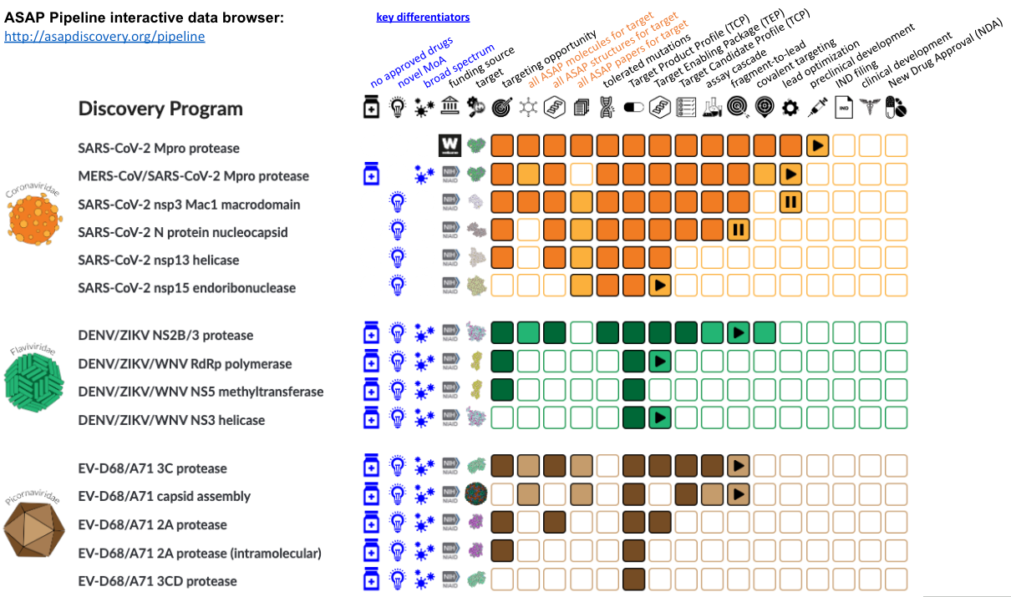

**Restoration of funding for years 4-5 is critical for maximizing the impact of AViDD.** The AViDD program request for applications requested applications for five-year U19 Centers. Within the original five-year budget and timeline, **ASAP has the potential to deliver 10 programs to critical milestones** that would enable their continued progression toward approval. However, due to the serial nature of drug discovery, **the recent announcement that the AViDD program is only funded for three years endangers most of these programs,** enabling us to only deliver four programs within three years:

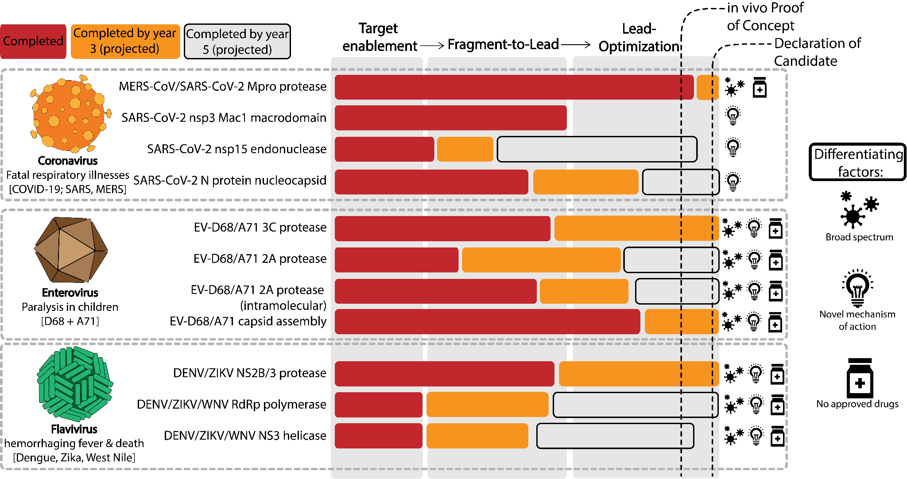

ASAP is an **open science** antiviral discovery consortium, aiming to not only produce clinic-ready antivirals, but also to nucleate a global pipeline of antiviral discovery for pandemic preparedness. To meet this objective, **we have focused our efforts on reporting all useful scientific outputs openly**. These outputs are currently hosted at the ASAP Discovery Consortium website [<http://asapdiscovery.org>], but we are working to ensure that all data products generated by ASAP are rapidly pushed into community standard data and reagent repositories in accordance with FAIR principles. Even though we have not yet advertised our open science outputs—as they are still in prototype form—we have had over 691 distinct new users of the website from 48 countries over the reporting period.

This progress report focuses on these publicly available open science outputs as tangible deliverables from each Project and Core, rather than reporting scientific findings only to the NIH via closed progress reports. Each Project and Core lists a brief summary of activities and findings, with the main focus of reporting on publicly accessible research products that can accelerate antiviral discovery globally (as well as advance ASAP’s mission of delivering clinic-ready antivirals). This is done in a manner that conforms to the **ASAP IP and Open Science Policy** established by Project 6: Preclinical Development, which balances the need for ensuring ASAP antivirals are developed for global equitable and affordable access while maximizing our ability to engage in open science to disseminate research products useful to other antiviral discovery efforts.

The **ASAP IP and Open Science Policy** aims to achieve the **ASAP Priorities** by leveraging a **minimum viable defensive patent strategy** in which ASAP Project 5: Lead Optimization will identify antiviral compounds it intends to develop (likely a single compound, potentially up to three compounds) and file a composition of matter patent to on *only* these compounds (rather than a broad genus), requesting the earliest possible filing date. This enables ASAP to disclose all other compounds in Discovery Programs that have not yet reached Project 5, as well as disclose data for compounds ASAP is not aiming to clinically develop that are sufficiently differentiated in quarterly disclosure reviews. All data is disclosed once the patent is published.

ASAP is then able to use a **maximally permissive licensing strategy** to ensure antivirals discovered by ASAP can be developed for globally equitable and affordable access. ASAP member organizations can license the patent to development partners in a manner that prioritizes non-exclusive, royalty-free, global licenses that require development partners to waive exclusive rights over regulatory data and market approval and right of reference for registration purposes, and obligate them to publish clinical trial protocols and results in accordance with WHO guidelines and recommendations. In the event of an emergent pandemic, if no development partners can meet these licensing conditions, the patent may be granted in a conditional exclusive fashion for high-income countries (HICs) provided certain conditions are met, including at least 50% of the manufacturing capacity is reserved for low- and middle-income countries (LMICs). Finally, in the event of a WHO declaration of Public Health Emergency of International Concern, development partners are obligated to sublicence to the Medicines Patent Pool or other equivalent mechanism (possibly subject reasonable tiered royalties on sales in HIC or UMIC).

A public explainer of the rational for this approach is provided at: <https://asapdiscovery.org/open-science/>

The open research outputs focus on two areas of the ASAP website:

The **ASAP Pipeline** [<http://asapdiscovery.org/pipeline>] is the first fully open drug discovery pipeline, where researchers can inspect each stage of the discovery process to access all data and resources we have generated for each Discovery Program. This resource will be highly valuable to others working on the same (or related) antiviral target proteins or seeking to identify potent chemical tools to validate antiviral target biology.

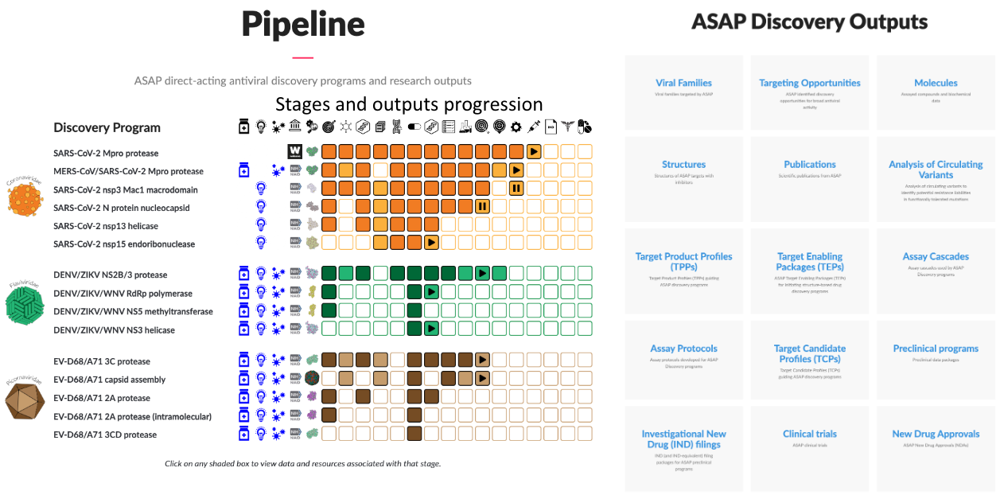

These **ASAP Discovery Outputs** [<http://asapdiscovery.org/outputs>] page organizes all research outputs from ASAP in a conveniently accessible manner. These include:

**Targeting Opportunities:** A **Targeting Opportunity** provides an overview of the opportunity for targeting new antivirals to a specific viral target protein and mode of action. This overview summarizes relevant information for drug hunters, including the relevant domain and binding sites to target, notable chemical matter, rationale for antiviral effects, and other useful information in prosecuting a discovery campaign against the target.

**Molecules:** ASAP is synthesizing and assaying new molecules against numerous antiviral targets, and posting these publicly as part of our open science mission. We disclose molecules we have synthesized, their target and antiviral activities, and other ADMET properties measured in our discovery campaigns according to the ASAP IP and Open Science Policy. Instead of requiring MTAs, we provide Enamine catalog numbers to enable researchers to purchase these molecules directly at cost.

**Structures:** Diamond Light Source is a full partner in ASAP, producing numerous X-ray structures of molecules bound to antiviral targets. All structural data (including apo structures, fragment screens, and complexes with small molecule antivirals designed and synthesized by ASAP) is disclosed through the Fragalysis collaborative interactive platform and ultimately the Protein Databank (PDB). **In 2023, ASAP deposited 601 structures in the PDB, amounting to 6% of *all new X-ray structures deposited in the PDB in 2023.*** ASAP has indexed or posted data for numerous apo X-ray structures and X-ray fragment screens it has generated at <https://asapdiscovery.org/outputs/structures/>

**Publications:** ASAP aims to rapidly preprint and ultimately publish all findings in scientific journals. ASAP has generated eight publications and preprints to date: <https://asapdiscovery.org/outputs/publications/>

**Target Mutational Data:** Deep mutational scanning (DMS) data helps identify mutations in the target that are functionally tolerated and could lead to resistance should these mutations abrogate binding of antivirals. ASAP is using multiple techniques to rapidly generate DMS data for all targets of interest in order to inform the discovery of resistance-robust direct-acting antivirals. ASAP is also pursuing analysis of circulating variants of SARS-CoV-2 and other viruses to identify functionally tolerated mutations to inform resistance-robust inhibitor discovery. ASAP has used the analysis of circulating variants to define potential resistance residue maps for all SARS-CoV-2 target proteins: <https://asapdiscovery.org/outputs/mutation-data/>

**Target Product Profile (TPP):** A Target Product Profile (TPP) describes the desired characteristics of a drug product aimed to treat a particular disease or set of diseases. All ASAP TPPs are draft TPPs intended to help guide the development of target candidate profiles (TCPs) for antiviral discovery within the ASAP Discovery Consortium. ASAP works with stakeholders around the globe to align TPPs to ensure they meet the needs of communities and fulfill our mission of global, equitable, and affordable access to antiviral therapies. All ASAP draft TPPs (including SARS-CoV-2, SARS-CoV-2/MERS-CoV, DENV/ZIKV, EV-D68/A71 adult, and EV-D68/A71 child) are available at: <https://asapdiscovery.org/outputs/target-product-profiles/>

**Target Candidate Profile (TCP):** A Target Candidate Profile (TCP) describes the objectives an ASAP drug discovery program aims to achieve to produce a preclinical candidate. Our TCPs are informed by the corresponding Target Product Profiles (TPPs) for the corresponding disease. All ASAP TCPs are available at: <https://asapdiscovery.org/outputs/target-candidate-profiles/>

**Assay Protocols:** ASAP aims to ensure that all protocols for biophysical, biochemical, and antiviral assays developed and/or run in ASAP Cores are fully and easily reproducible by industry or academic groups engaging in antiviral discovery. All protocols are available at: <https://asapdiscovery.org/outputs/assay-protocols/>

**Assay Cascades:** An assay cascade is a defined set of assays and progression criteria used by a drug discovery program to achieve its Target Candidate Profile (TCP) goals in a time- and cost-effective manner. ASAP has made its assay cascades available at <https://asapdiscovery.org/outputs/assay-cascades/>

**Target Enabling Package (TEP):** A Target Enabling Package (TEP) is a complete data package needed to enable structure-based drug discovery against an antiviral target. Pioneered by the Structural Genomics Consortium, each TEP contains relevant protein constructs and plasmid resources for one or more viral family members, protein expression and purification protocols, crystallization conditions, structures from an X-ray fragment screen at the Diamond Light Source XChem facility, small molecule hits, and biochemical assay protocols with at least one validated inhibitor with quantifiable activity. All 14 ASAP Target Enabling Packages completed or in progress are available at: <https://asapdiscovery.org/outputs/target-enabling-packages/>

**Hit-to-Lead Progression:** ASAP originally aimed to produce high-quality lead compounds for nine viral targets within five years. ASAP has completed one hit-to-lead program (SARS-CoV-2 nsp3 Mac1 macrodomain), creating a toolbox of useful compounds and leads, and generating data for 1107 compounds with Tier 1 ADMET data. Three other programs (EV-D68/A71 VP capsid, EV-D68/A71 3C protease, and DENV/ZIKV NS2B/3 protease) are currently in progress and will soon be posting data publicly once quality checks have passed. All hit-to-lead data to date is available at <https://asapdiscovery.org/outputs/molecules/>

**Covalent Targeting:** ASAP is exploring covalent targeting strategies for cysteine and serine proteases. Data for covalent fragment screens against DENV, WNV, and ZIKV NS2B-NS3 protease are available at: <https://asapdiscovery.org/outputs/molecules/>

**Lead Optimization:** ASAP originally aimed to pursue five lead optimization programs within five years, producing at least three candidates for preclinical development. ASAP currently has one Discovery Program in Project 5: Lead Optimization targeting MERS-CoV/SARS-CoV-2 (which has now achieved an *in vivo* animal efficacy proof of concept milestone) in transition into Project 6: Preclinical Development. Following the ASAP IP and Open Science Policy, ASAP has disclosed activity data for 360 compounds it does not intend to carry forward for development at: <https://asapdiscovery.org/outputs/molecules/>

ASAP will similarly disclose data from **Preclinical programs** and data packages for **Investigational New Drug (IND) filings** once Discovery Programs reach this stage, in accordance with the ASAP IP and Open Science Policy.

ASAP has initiated more than 14 Discovery Programs in Project 2: Target Enablement. Based on progress in this first grant year, a number of these Programs have the potential to produce antiviral candidates for preclinical development by the end of the three-year initial funded period (with a one-year no-cost extension):

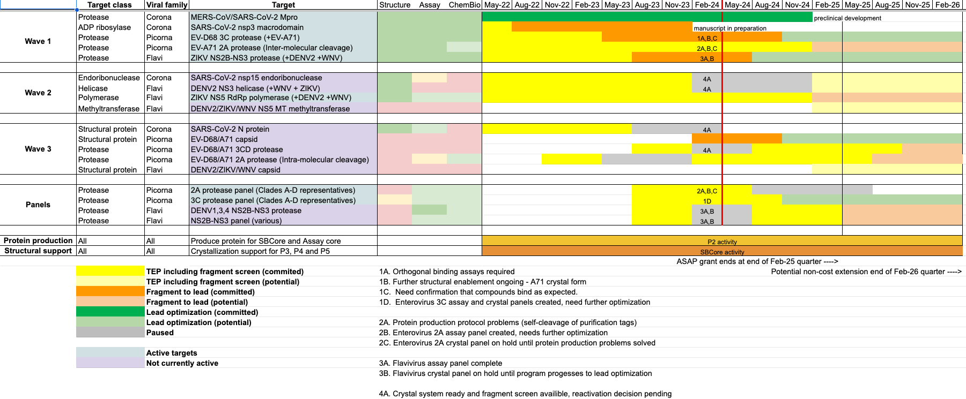

**The ASAP platform has been extremely productive in year 2 after reaching full speed.** We have made and assayed over 6264 compounds to date over all Projects:

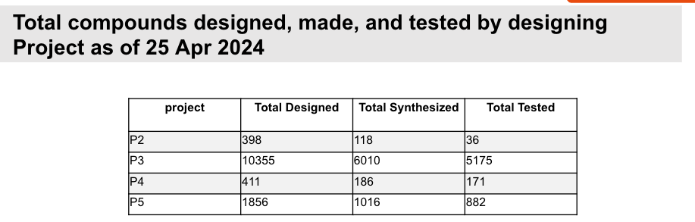

ASAP Discovery Programs have progressed rapidly compared to year 1: Over 6,193 compounds were synthesized and assayed in year 2 out of 16,954 total:

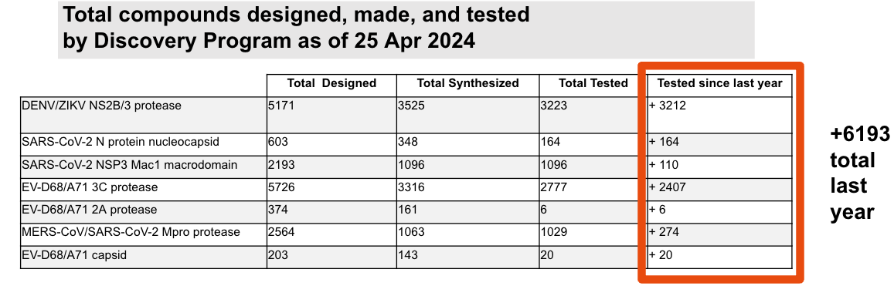

Core and CRO productivity has also been very high, with nearly 17,000 assays run to date.

# 

# Structural biology productivity has been similarly high: Over 18,353 X-ray datasets have been collected, 601 structures deposited in the PDB in 2023 (which was 6% of *all* new X-ray structures deposited by anyone on the planet in 2023), and 223 new X-ray structures deposited in 2024 so far. Tractable crystal systems for 15 proteins have been developed across 8 targeting opportunities, and X-ray fragment screens for many of these have already been completed and shared publicly.

# 

# C. Significance

The Administrative Core coordinates all aspects of ASAP, and is essential to its operation.

This core is required to:

* Aid efficient execution of Research Projects;
* Coordinate strategic and timely transitions of discovery programs among research projects;
* Shepherd progress through sequential stages of the discovery pipeline;
* Oversee efficient management of Scientific Cores supporting these efforts; and
* Assist in the rapid dissemination of all scientific output to the global antiviral discovery community.

# 

# D. Plans

Plans for the next project period include:

* Continue activities to ensure smooth operation of ASAP Projects, Cores, and Discovery Programs.
* Produce a live view of all open research products from ASAP and project status on the ASAP website.
* Ensure that all research products and reagents are rapidly delivered to community standard repositories in accordance with FAIR principles
* Continue to refine our approach to extracting maximum value from ASAP Investigator, SAB, and NIAID meetings.
* Migrate the Antiviral Drug Discovery Open Science Forum [<http://openantivirals.org>] website to a stand-alone entity that multiple AViDD Centers can use to share research outputs, resources, molecules, reagents, talks, and other antiviral dissemination materials.
* Organize ASAP Annual Meeting to coordinate personnel, conduct retrospective project reviews, operational assessments and refinements, and strategic planning.

# 

# 

# Human Subjects

Not Applicable

# Inclusion of Women and Minorities in Clinical Research

Not Applicable

# Human Subjects Education Requirement

Not Applicable

# Human Subjects Education Requirement

Not Applicable

# Select Agent Research

Not Applicable

# Human Embryonic Stem Cell Line(s) Used

Not Applicable

# 

# 

# Publications and Preprints

In the reporting period, ASAP has produced the following:

Ryan M Lithgo, Charlie W. E. Tomlinson, Michael Fairhead, Max Winokan, Warren Thompson, Conor Wild, Jasmin Aschenbrenner, Blake Balcomb, Peter G. Marples, Anu V. Chandran, Mathew N. Golding, Lizbe Koekemoer, Eleanor P. Williams, SiYi Wang, Xiaomin Ni, Elizabeth M. Maclean, Charline Giroud, Tryfon Zarganes-Tzitzikas, Andre Schutzer de Godoy, Mary-Ann Xavier, Martin Walsh, Daren Fearom, Frank von Delft. **Crystallographic Fragment Screen of Coxsackievirus A16 2A Protease identifies new opportunities for the development of broad-spectrum anti-enterovirals**. bioRxiv [**Preprint**]. 2024-04-29. Available from: https://doi.org/10.1101/2024.04.29.591684

*We describe an X-ray fragment screen of a closely related protein to EV-A71 2A protease"*

**Contributing Projects:** Project 2

**Contributing Cores:** Structural Biology Core

--

Xiaomin Ni, Andre Schutzer de Godoy, Peter George Marples, Michael Fairhead, Blake H Balcomb, Matteo P. Ferla, Charles W. E. Tomlinson, Siyi Wang, Charline Girould, Jasmin Cara Aschenbrenner, Ryan Lithgo, Max Winokan, Anu V. Chandran, Warren Thompson, Mary-Ann Elvina Xavier, Eleanor Williams, Martin A. Walsh, Daren Fearon, Lizbe Koekemoer, Frank von Delft. **Crystallographic fragment screening delivers diverse chemical scaffolds for Zika virus NS2B-NS3 protease inhibitor development**. bioRxiv [**Preprint**]. 2024-04-29. Available from: https://doi.org/10.1101/2024.04.29.591502

*We describe an X-ray fragment screen of ZIKV NS2B-NS3 protease, resolving 48 protein:ligand complexes*

**Contributing Projects:** Project 2

**Contributing Cores:** Structural Biology Core

--

Andre Schutzer Godoy, Nathalya Cristina de Moraes Roso Mesquita, Gabriela Dias Noske, Victor Oliveira Gawriljuk, Ryan M Lithgo, Blake H Balcomb, Jasmin Cara Aschenbrenner, Charles W. E. Tomlinson, Max Winokan, Jenke Scheen, Peter George Marples, Anu V. Chandran, Xiaomin Ni, Warren Thompson, Michael Fairhead, Daren Fearon, Lizbe Koekemoer, Mary-Ann Elvina Xavier, Martin Walsh, Glacius Oliva, Frank von Delft. **High-throughput crystallographic fragment screening of Zika virus NS3 Helicase**. bioRxiv [**Preprint**]. 2024-04-29. Available from: https://doi.org/10.1101/2024.04.27.591279

*We describe an X-ray fragment screen of ZIKV NS3 helicase*

**Contributing Projects:** Project 2

**Contributing Cores:** Structural Biology Core

--

# Project Generated Resources

See Project reports for lists of Project generated resources originating from each Project.

The Administrative Core has also delivered the following resources:

ASAP held its **NIAID Annual Reverse Site Visit** to review detailed progress over the second award year.  **slides:** [https://docs.google.com/presentation/d/1Gn39CtEpUf2feALCmiJLSzm0BxgEjWqIS_5nAjVl0EE/edit](https://docs.google.com/presentation/d/1Gn39CtEpUf2feALCmiJLSzm0BxgEjWqIS_5nAjVl0EE/edit?usp=sharing)  
(Note: this presentation contains CONFIDENTIAL slides.)

The **ASAP website** provides access to all open data outputs from ASAP:  
<http://asapdiscovery.org>

In the absence of an NIAID-driven mechanism for collaboration and coordination among AViDD Centers, ASAP has initiated the **Antiviral Drug Discovery Open Science Forum** [<http://openantivirals.org>]. The Open Science Forum features monthly talks from scientists from NIH-funded Antiviral Drug Discovery (AViDD) Centers who elect to provide updates on target priorities, advertise available resources and reagents, disclose chemical matter (such as hits, leads, and chemical tool compounds) and associated antiviral data, share findings regarding in vivo efficacy models, discuss downstream development and translation models, and share ideas. Talks are public, recorded, and shared online along with links to relevant resources and reagents for the benefit of other AViDD Centers and the global antiviral drug discovery community. An unrecorded discussion with the speakers follows each pair of talks for those that wish to discuss the science behind the work more deeply. It has held monthly meetings since October 2022 : 19 meetings, 37 talks, numerous linked antiviral discovery open science resources. Recorded talk videos are hosted at: <https://www.youtube.com/@AViDD-OSF/videos>

